**Lab - Installing a Network Printer onto a Windows**

**Overview**

In this lab, we see to how easily install a network printer onto a Windows client. If the printer is published to Active Directory or shared on the network, we can reach the print server from anywhere on the network just by going to a run line or the search window and typing in \\<server name>. When the server shares pops up, we will be presented with all the shares on the server.

Start your Windows 7 VM. From your Windows 7 desktop, hit the Windows + R keys on your keyboard. If you have a Mac or Apple as a host, use the search window.

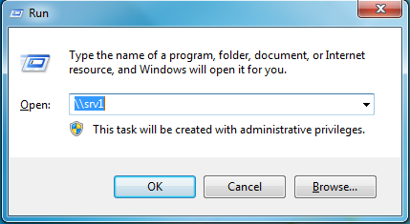

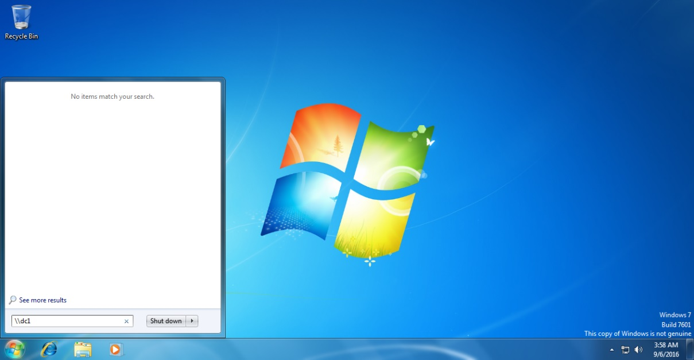

Either way, when you hit enter, you will be presented with all the available shares on your server. My print server is SRV1; yours may differ. I see the Bobcat printer is available. Let’s say that I have just installed a brand new, pristine HP workstation for the accounting department. I’m on the second floor, and my server is in the server room in the basement.

By doing a “whack, whack” (\\) from the run line and adding in the name of the computer or server, I can gain access to the shares including printers from my current location. I right click on the printer, select Connect from the context menu, and we are done!

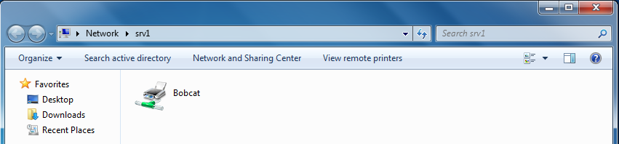

This works because I have administrative access to the shares. Not everyone will see the same shares unless they too have administrative access.

The new PC pulls down the Windows 7 for the Bobcat printer, and we are prompted to accept a certificate for the print driver. We select “Install driver, ” and the installing of the shared Bobcat printer completes.

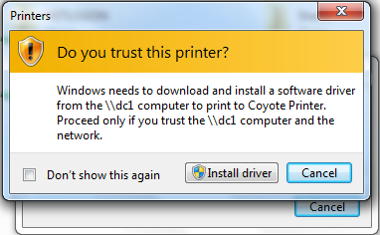

From my Window 7 client, if I go to Start, Devices, and Printers I see my newly installed shared printer is available, and the green check mark means the printer is now by default printer for all print jobs.

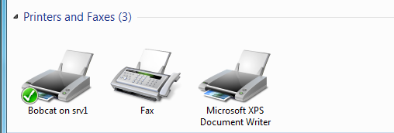

**Powershell**

Get-Command –Module PrintManagement – Shows all the commands available for the PrintManagement module.

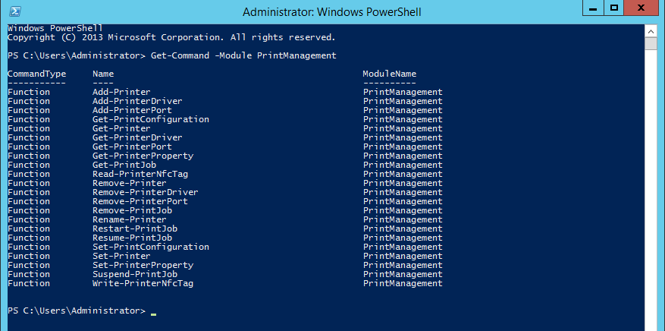

Get-Help <cmdlet_name > -Detailed - Detailed information about the syntax for any cmdlet in Powershell

(Try thinking about other PowerShell modules where these commands could be used, not just the PrintManagment module. The commands would work with all Powershell modules.)

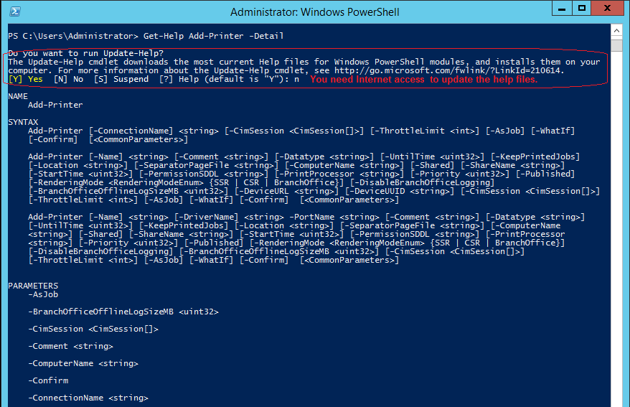

Get-Help <cmdlet_name > -Examples - Examples of the commands

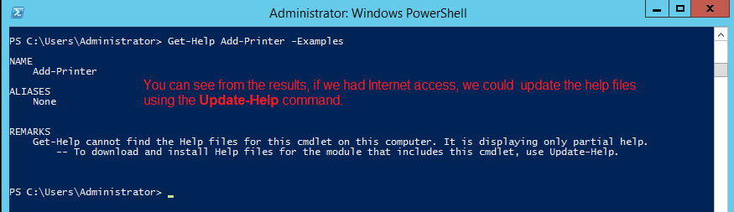

Get-PrinterDriver - Display the list of printer drivers in the system.

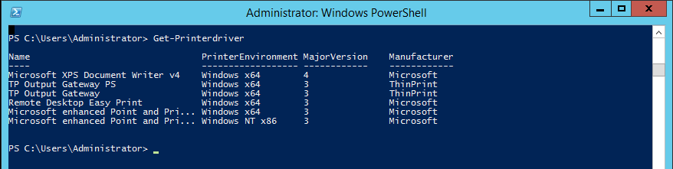

**Summary**

The idea of having shared network printers is to reduce the cost of everyone needing their own printer. This seldom is the case. Management usually has a need for a personal computer as does the receptionist and others. Regardless if the printer is a document center or an HP LaserJet 4200, if the printer has network capability, the printer can be directly shared out on the network.

End of the lab!